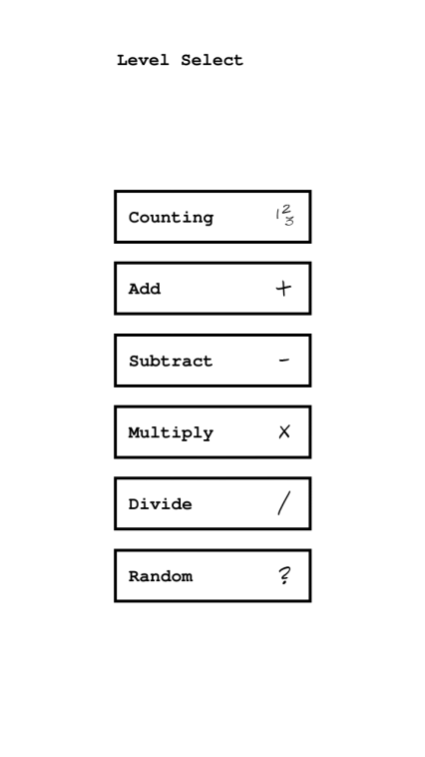How to play!

## 1

In all game modes (single or multiplayer, versus or cooperative) of Math Dots you can choose to play one of the following game categories.

## C:\Users\Erik\Dropbox\Camera Uploads\2013-01-20 22.55.36.png2

The goal in Math Dots is to complete each math puzzle by clicking the dots in the right order and create the correct sequence. In this example the category is counting, and the puzzle is solved by doing the count from 1 to 9 in order. If the clicked dot is correct the dot will light up green, otherwise red.

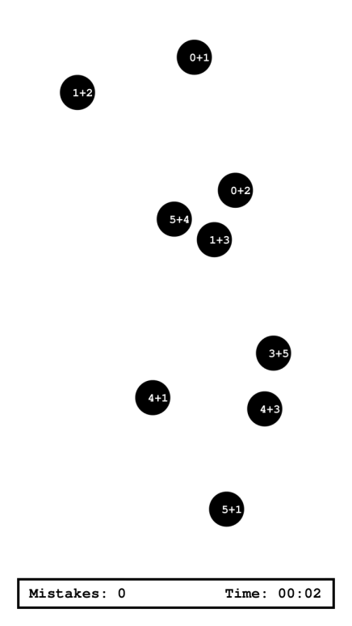

## 3

In this game the category is adding and the player must do the math in each dot to figure out the sequence. The first dot is: (0+1) since it equals 1. The second is 0+2 etc. The procedure is similar in all the other categories.

After each game the player is given a score based on time and number of mistakes. The best results are saved in the high score.

## C:\Users\Erik\Dropbox\Camera Uploads\2013-01-20 22.57.35.png4

In multiplayer mode two people can play together on a split screen. In cooperative mode the players work on the same puzzle and help each other to solve it.

## C:\Users\Erik\Dropbox\Camera Uploads\2013-01-20 22.57.55.png

## 5

In versus mode the players competes in finishing the puzzle first and with the least amount of mistakes.